Individual Logbook

Week 12
Dave Sushames
2026
Contents
Table 1
Discussion 1

Table
Category | Hours Completed
Team meetings | 4
Client meetings
Advisor meetings | 1
Research | 3h 5m
Development | 7h 15m
Testing
Documentation | 10
Logbook preparation | 1
Other
Total hours for this week | 26h 20m
Running total of hours completed for Capstone

Logbook content notes
Team meetings:
Monday 12:30-2:30
Tuesday 10-12
Client meetings:
Advisor meetings:
Tuesday 9-10 Bryce meeting
Documentation:
Monday 9-10: Working on the poster, trying alternative ways for sections to be laid out.
Monday 10-12:30 Helping Sam with his flow charts depicting the report-making process
Monday 3-4: Back to the poster, experimenting more with layouts.
Tuesday 12:30-3: Continuing work on poster, checking with the team for the exact sections we want on it:
Background: About the client
Rationale: Why this project is required
Objective: What the project needed.
Method/Approach/Process: How we did it.
Artefacts: the things that were made.
Challenges: Technical, Administrative. Issues we ran into.
Findings: Metrics/outcomes table. What is better for what.
Future work: What can be done in the future to further this?
Wednesday 8:30-11:30 Poster has as much detail as can be done for now, until more actual work has been completed 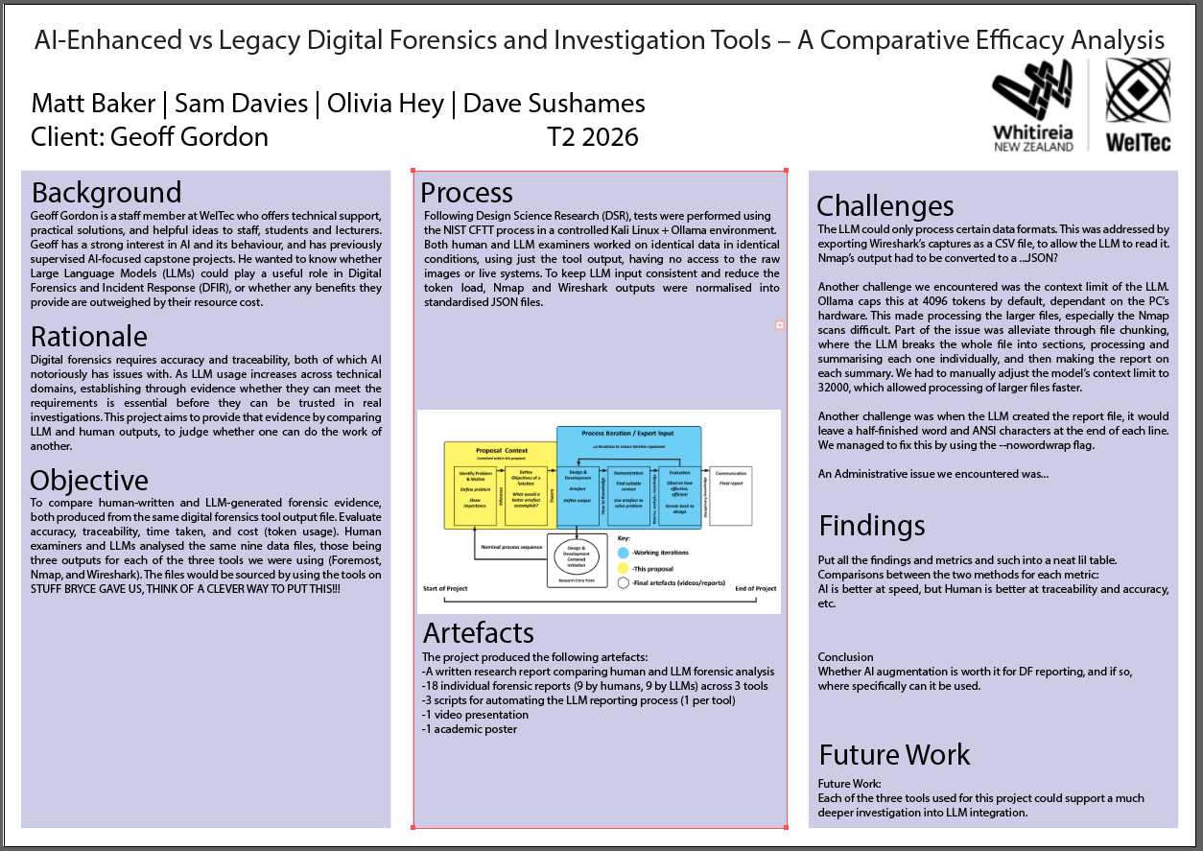
2:30-4: Started working on making a report on a pcap file.
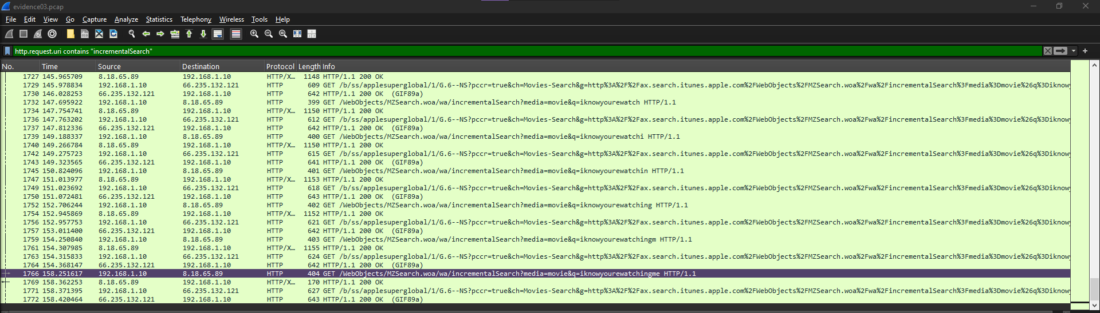
Thursday 8:45 – 2:30pm: Finished the Wireshark report on evidence03.pcap.
